Hosna Ghaderi
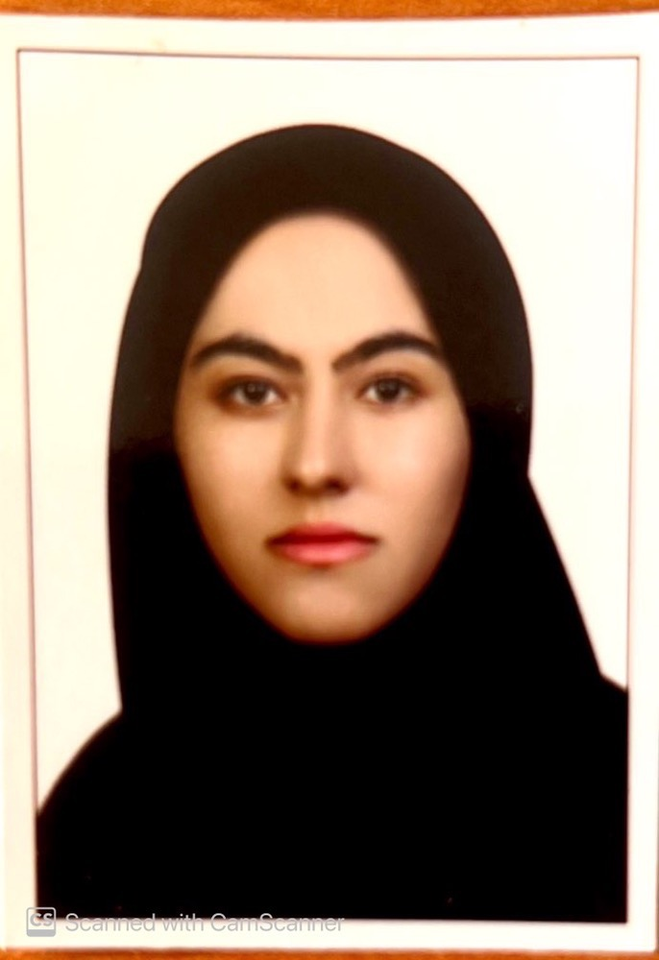  CONTACT  Address:  Kurdistan - Sanandaj - Pasdaran Boulevard - Kurdistan University of Medical Sciences-- School of Paramedical Sciences - Department of Laboratory Sciences  Phone:  +98-9189794168  Email:  hosnaghaderi1771@gmail.com  LANGUAGES  Kurdish  Farsi  English |  | OBJECTIVE  Faculty of Laboratory Sciences Department of Paramedical school.  WORK EXPERIENCE  - Laboratory expert of Dr. Seyed Al-Shohadayi Hospital in Sanandaj (2014-2016).  - Faculty of Laboratory Sciences Department of Paramedical school (2019-yet).  EDUCATION  - (MSc) Medical Immunology- Kurdistan University of Medical Sciences, Iran (2014-2018)  - (BSc) Medical Laboratory Sciences, Kurdistan University of Medical Sciences, Sanandaj, Iran (2010-2014).  ADDITIONAL SKILLS  - All routine and specialized laboratory tests  - Cell culture  - Flowcytometry  - Real time–PCR  - Quality control  - Power point  - Word  - Excel  - Camtasia  - Adobe Connect  - iSrpring  Theoretical teaching:  - Medical Immunology of Medical laboratory sciences  - Medical Immunology of Anesthesiology  - Immunohematology  - Laboratory preparations  - Quality control in the medical diagnostic laboratory  - Principles of safety and protection in the medical diagnostic laboratory  - Seminar  Practical teaching:  - Medical Immunology  - Immunohematology  - Intership in Laboratory sciences  History of research activities:  - Evaluation of effective medicinal plants in the dysmenorrhea treatment; A systematic review (Completed).  - 2. Investigation of the effect of very low glucose concentration on the properties of human adipose tissue-derived mesenchymal stem cells (ASCs) (viability, doubling time, immunomodulatory property, stemness, aging and migration) ( in process).  - 3. Evaluation of the effect of platelet-derived microvesicles on drug resistance in acute myeloid leukemia cells HL60 (Completed).  - 4. Evaluation of the relationship between ABO and RH blood groups with IgG antibody titer in healed Covid 19 patients ( in process).  Executive activities:  - Director of EDO in paramedical school of Kurdisran University of Medical Sciences (2020-yet).  - Member of the Self-Evaluation Committee of the Laboratory Science Department in Paramedical Science school(2019-yet).  - Member of empowerment committee in Kurdistan University of Medical Sciences(2021-yet).  - Member of planning committee in Kurdistan University of Medical Sciences(2021-yet).  - Member of Educational Leveling Council committee in Kurdistan University of Medical Sciences(2020-yet).  - Member of the Education Research Council committee in Kurdistan University of Medical Sciences(2020-yet).  - Member of the Virtual Education Committee in Paramedical Science school(2020-yet).  - Member of the evaluation and promotion of Online and computer-based exam committee in Kurdistan University of Medical Sciences(2020-yet).  Participate in the Internal Congress:  - Shahid Motahari Educational Festival-2020-2021  - Immunology Congress in Ahvaz,Iran-2021-2022  Workshopes:  - Organizer of Immunotherapy in Cancer workshop in paramedical Sciences school of Kurdistan University of Medical Sciences -2019  - Lesson plan and course plan-2019  - Virtual training design-2020  - Introduction to Adobe Connect Software-2020  - Meta-evaluation of descriptive and OSCE test analysis-2020  - New OSCE-2020  - Design of descriptive tests-2020  - Student evaluation-1-2020  - High quality content Production of Arman Mox-2020  - Student evaluation-2 (design of multiple choice questions)-2020  - Curriculum planning (curriculum development and revision)-2020  - Student evaluation-3 (OSCE)-2020  - Shahid Motahari Educational Festival-2020  - Innovative processes-2020  - Introduction to Arman Mox and the software needed to produce Arman content-2020  - Social accountability in the health research system-2020  - Introduction to Camtasia software-2021  - Evaluation of material toxicity effect with MTT test-2021  - Social Factors affecting Health and Covid – 19-2021  - Standardization on laboratory animals-2021  - Questionnaire design-2021  - Method of Essensial oil preparation and Herbal extracts-2021

